Friends of the Guernsey County Library
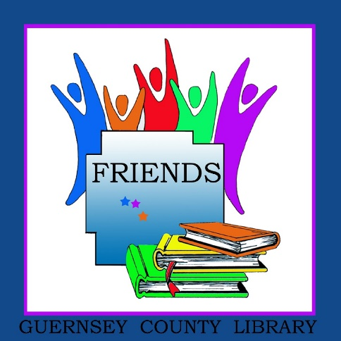
The Friends of the Library is a non-profit association whose members share a passion for books and learning. Our Friends help support the library, present special programs and encourage reading and use of the library through fundraising and personal involvement.
2020 Membership Form
(circle membership level)

Seniors (62 up) and currently enrolled students - $10

Individual Membership - $15

Family [parent(s) and children] - $25

Patron - $50

Corporate - $100

Donation beyond/instead of membership - $ __________________________

Checks payable to the Friends of the Guernsey County Library and may be submitted at any branch or sent to Laurie McKnight, 820 N. 8th St. Cambridge, OH 43725

Contact Information:
Name (please print): __________________________________________

Email address: __________________________________________

Street address (include city and zip) __________________________________________

__________________________________________

Phone(s): __________________________________________

The Friends need help, always. Which task(s) or groups interest you?

Newsletter or Webpage Welcoming and Refreshments Other (eg., design or public speaking,
Special Events/Book Sale Membership Development reading to children, etc)
________________________________

Questions? Please call Joan Albaugh, President at 740-489-5163 or Michele Hatcher, Vice President at 740-489-5045.

